

Kamala - Village Peepad
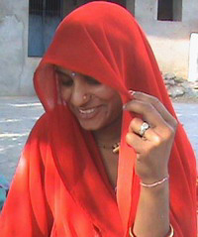
Kamala is in her mid twenties. She lives with her husband Madan Singh and one son in village Peepad. She is expecting another child and it is her seventh month of pregnancy. Her first child was born in a town called Nathdwara.

She has got two shots for Tetanus in the Immunization Camp being organized by Seva Mandir in this village. She is aware of the significance of immunizations for expecting mothers and small children.

Four years ago one of her friends was expecting. She delivered a baby-girl and began to have convulsions. The family of her friend got scared including Kamala and wanted to save her. So they took her to the hospital immediately. Kamala’s friend was saved but the incident imprinted fear on Kamla’s heart. She came to know later that her friend was not given the Tetanus vaccination.

Kamala wants to stay safe. Her sister-in-law cooperates with her and is a good friend of her. They both come to Immunization Camps to get Kamala vaccinated. She is happy that she does not have to go as far as 35 kilometers (in city Udaipur) for vaccination.

Please visit us at: www.sevamandir.org

